Dell Precision Tower 5820
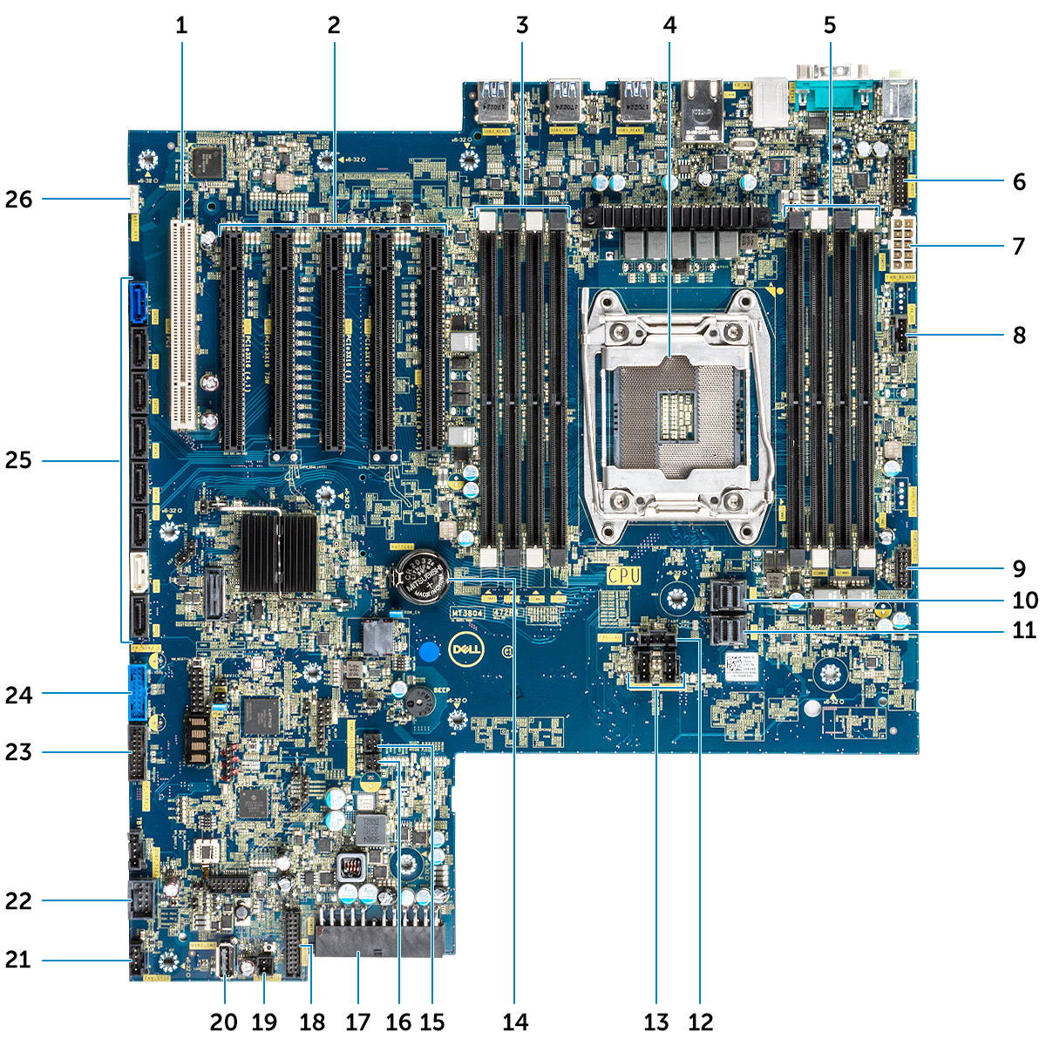
- Slot 6 PCI  - Slot PCI 3x16  - Memory slots  - CPU0  - Memory slots  - Front panel audio port  - Power CPU port  - System fan port  - Power control port  - PCIE0  - PCIE1  - CPU fan port  - System fan port | - Coin cell battery  - FLEX0 thermal sensor  - FLEX1 thermal sensor  - 24 pin power cable  - Front panel port  - Power remote  - USB 2_INT  - System fan 0  - USB 2_flex  - Front panel USB3.2 port  - Front panel USB3.1 port  - SATA 0, 1, 2, 3, 4, 5 and ODD 0, 1 ports  - VROC_key

